SDLC Model

We use the Software Development Life Cycle (SDLC) approach to systematically guide the software development process. The main goal of SDLC is to enhance software quality, reduce errors, and ensure the final product is delivered on time and within budget  
see table 1.1

1. Requirements  
Requirement phase is the first phase of the waterfall model. In this phase the requirements of the system are collected and documented. This phase is very crucial because the next phases are based on this phase  
  
2. Design  
Design phase is based on the fact how the software will be built. The main objective of the design phase is to prepare the blueprint of the software system so that no problems are faced in the coming phases and solutions to all the requirements in the requirement phase are found  
  
3. Implementation  
In this phase, hardware, software and application programs are installed and the database design is implemented. Before the database design can be implemented, the software has to go through a testing, coding, and debugging process  
  
4. Verification  
In this phase the software is verified and it is evaluated that we have created the right product  
  
5. Maintenance  
when the system is ready and users start using it, then the problems that arise have to be solved time-to-time. Taking care of the finished software and maintaining it as per time is called maintenance

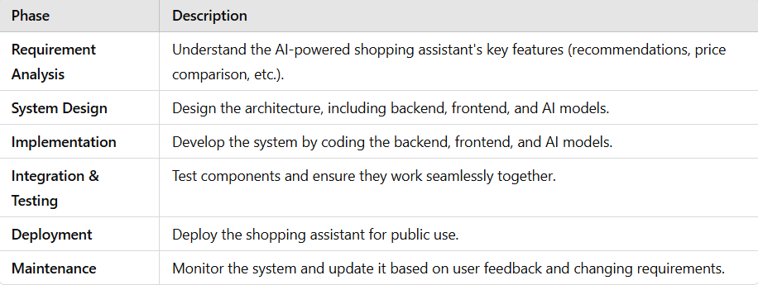Table 1.1  
  
  
  
  
  
  
  
  
  
**for our project: Testing**

**Objective:** Test the system to find and fix bugs, and ensure all parts of the system work well together

1. Perform unit tests to ensure individual components work correctly

2. Test the user interface for usability and functionality

3. Conduct integration testing to ensure that the backend, frontend, and AI models work seamlessly together

4. Run performance testing to see if the assistant handles real-time queries and interactions well

5. Address any bugs or issues that arise during testing.